Factory Acceptance Test Procedure
PRODUCT NAME | HiNAS Control Standard | SERIAL NUMBER | MS25-0013
YARD | HSHI | HULL NO. | 8283
CLASS | DNV | DATE | 2026-05-04
INSPECTOR | Chong Sangok

AVIKUS PROPRIETATY DATA
This document cotains confidential proprietary information.
Restricted to use only by Avikus employees or other persons authorized by Avikus in writing to use it.
Since it cotains Avikus trade secrets, you cannot view, use, copy, distribute, or disclose this material
without the prior written approval of Avikus.
Version | Description | Author/EDITED | Revised/Approved | Date
1.0 | First Draft | Dongheun Kang,  Jinhwan Park | Sangdeok Choi | 2025-07-02
1.1 | Minor Update | Dongheun Kang,  Jinhwan Park | Sangdeok Choi | 2025-07-03
1.2 | Comment Update | Dongheun Kang | Sangdeok Choi | 2025-07-10

Note: In this document, ‘HiNAS Control’ is used to denote both HiNAS Control and HiNAS Control Standard.

- Overview
  - Purpose
This document provides a comprehensive description of the Factory Acceptance Test (FAT) for HiNAS Control Standard. The following items are verified through this document:

- Verify that the configuration and quantity of the HiNAS Control Standard hardware are the same as those shown in the drawings (Appendix A) submitted with the MED-B certificate.
- Verify that the Serial Numbers of the hardware listed in the DoC document match those of the hardware actually installed onboard.
- Verify that the software version recorded in the SW install package used for installation matches the version in the actual product.
- Verify that the data from all navigation equipment connected to the overall system are received correctly and that the software functions operate properly.
- Verify that the connected hardware performs its functions correctly.

  - Test Environment
Unless otherwise specified, the following test conditions shall be applied uniformly during the Factory Acceptance Test (FAT):
∙ Temperature: 25 °C ± 10 °C
∙ Atmospheric Pressure: Normal ambient pressure
∙ Humidity: 20% to 80%

  - Test Site
The test shall be conducted on board

  - Applicable Document
    - EC-TYPE EXAMINATION CERTIFICATE (MODULE B)
MEDB0000BWN (Revision no. 1)
    - Drawing
Approval Drawing of the vessel subject to FAT. (Appendix A.)

    - Inspection Report
Inspection Report for the item subject to inspection
    - SW Installation Report
SW Installation Report for the item subject to software installation

- Information about the test setup
  - Components List (MEDB0000BWN)
The components list specified in the EC-Type Examination Certificate is as follows.
No. | Type | Type Designation | Maker | Note/description/limitation
1 | Server | Optiplex XE4 Tower with damping kit TVK-XE4-TV or TVK-XE4-TH | Tetradyne | At least two per installation.
2 | Client | Optiplex XE4 Tower with damping kit TVK-XE4-TV or TVK-XE4-TH | Tetradyne | Optional. In server/client config, two per installation
3 | Monitor | TIMX-W270 or TIMX-W320 or  TIMX-UW584 | Tetradyne | System may be installed with two monitors in same installation.
4 | Keyboard with  Trackball | RKTE85B2448- W-MC1 | NSI | To be installed with each delivery
5 | Serial to Ethernet | Nport-5450i | Moxa | Minimum one per installation
6 | Network switch | EDS-G508E | Moxa | Minimum one per installation
7 | Firewall | FGR-60F | Fortinet | One per installation
8 | Selector switch | MPH 731 | Yokogawa | One per installation
9 | Dimmer | MKD002 | Yokogawa | One per installation
10 | UPS | 9SX1000IM or 9SX3000IM or 9PX1500iRTM | Eaton | Minimum one UPS per installation.
11 | Camera unit, incl. EO cameras and IR cameras | HiNAS Navigation | Avikus | Optional
12 | Junction box incl. Single Board Computer

  - Components’ Software Version
No. | Type | Type Designation | Software Version
1 | Heading Control System | T.B.D | T.B.D
2 | Remote Control System | T.B.D | T.B.D
3 | ECDIS | T.B.D | T.B.D
4 | HiNAS Control Standard |  | V2.0.4
5 | Operating System | ubuntu | 22.04

  - Test Preparation
    - Verification
Verify whether there are any non-compliant components by comparing the drawings of the FAT target vessel with the EC-Type Examination Certificate.
    - Installation
All components shall be fully installed on the test bed prior to testing.

    - Wiring
The test items shall be wired according to the wiring diagram of the FAT target vessel.
The selector switch and dimmer box are excluded from the wiring, as there are no external interface devices.
    - Power Input
After verifying that there are no wiring errors, system power shall be applied.
    - Software Installation
The SW is installed by ‘Manual: HiNAS Control Standard Installation Manual’ on MED-B cert.

- Factory Acceptance Test
  - Visual Inspection Test
    - Visual Inspection
No. | Test | Criteria | Result | Judgment
 |  |  |  | Pass | Fail
1 | Visually inspect the prepared test items for any visible damage or deformation | No damage or deformation |  | v

    - Verification of conformity
Verify that the FAT items conform to the Type Designation specified in the EC-Type Examination Certificate
※ For items not applicable, indicate "N/A" in the Result column and skip the test.
No. | Type | Type Designation | Qty | Criteria | Result | Judgment
 |  |  |  |  |  | Pass | Fail
1 | Server | Optiplex XE4 Tower with damping kit TVK-XE4-TV or TVK-XE4-TH | 2 | Type Designation conformity | Type Designation :  Optiplex XE4 Tower with damping kit TVK-XE4-TH  SER. NO. :  6K163G4  B85F4G4 | v
2 | Client | Optiplex XE4 Tower with damping kit TVK-XE4-TV or TVK-XE4-TH | 2 | Type Designation conformity | Type Designation :  Optiplex XE4 Tower with damping kit TVK-XE4-TV  SER. NO. :  D7W8VF4  5FV8VF4 | v
3 | Monitor | TIMX-W320 or  TIMX-UW584 | 2 | Type Designation conformity | Type Designatio :  TIMX-W320(32”)  TIMX-UW584(58.4”)  SER. NO. :  TM260408-019  TM260410-019 | v
4 | Keyboard with  Trackball | RKTE85B2448- W-MC1 | 2 | Type Designation conformity | Type Designation :  RKTE85B2448-W-MC1  SER. NO. :  2026.42300.038  2026.42300.019 | v

No. | Type | Type Designation | Qty | Criteria | Result | Judgment
 |  |  |  |  |  | Pass | Fail
5 | Serial to Ethernet | Nport-5450i | 2 | Type Designation conformity | Type Designation :  Nport5450i  SER. NO. :  TBFBE1072358  TBFBE1072336 | v
6 | Network switch | EDS-G508E | 2 | Type Designation conformity | Type Designation :  EDS-G508E  SER. NO. :  TBFCD1051368  TBFCD1051364 | v
7 | Firewall | FGR-60F | 1 | Type Designation conformity | Type Designation :  FGR-60F  SER. NO. :  LNSBFJDJ8S | v
8 | Selector switch | MPH 731 | 1 | Type Designation conformity | Type Designation :  MPH 731  SER. NO. :  YOKOGAWA에서 일괄 공급 | v
9 | Selector Switch Dimmer | MKD002 | 1 | Type Designation conformity | Type Designation :  MKD002  SER. NO. :  YOKOGAWA에서 일괄 공급 | v
10 | UPS | 9PX3000iRTM | 1 | Type Designation conformity | Type Designation :  9PX1500iRTM  SER. NO. :  GA41T45040 | v

No. | Type | Type Designation | Qty | Criteria | Result | Judgment
 |  |  |  |  |  | Pass | Fail
11 | Camera unit, incl. EO cameras and IR cameras | HiNAS Navigation | 1 | Type Designation conformity | Type Designation:  HiNAS Navigation  SER. NO. :  Camera unit :  SC0004-NCH01-25157 | v
12 | Junction box, incl. Single Board Computer |  | 1 | Type Designation conformity | Type Designation:  HiNAS Navigation  SER. NO.  Junction box :  SC0005-NJB01-26021  Single board computer :  NAS-HUCX11250017  EMC -filter :  SZ0014-EMC01-116  SMPS :  2025-131 | v

Verify that the types and quantities of equipment installed on board the vessel match those specified in the Declaration of Conformity and the submitted drawings.

No. | Test | Criteria | Result | Judgment
 |  |  |  | Pass | Fail
1 | Verify that the configuration and quantity of the HiNAS Control Standard hardware are the same as those shown in the drawings |  |  | v
2 | Verify that the Serial Numbers of the hardware listed in the DoC document match those of the hardware actually installed onboard. |  |  | v

  - Functional Test
    - Dimmer
Verify the operation of the monitor's dimming function
- For monitors not applicable, indicate "N/A" in the Result field and omit the test
No. | Test |  | Criteria | Result
 |  |  |  |  | Pass | Fail
1 | Verify whether the brightness can be adjusted by pressing the “-” and “+” buttons on the OSD Remote Control Unit of model TIMX-UW584. |  | Brightness adjustable |  | v
 | For reference | 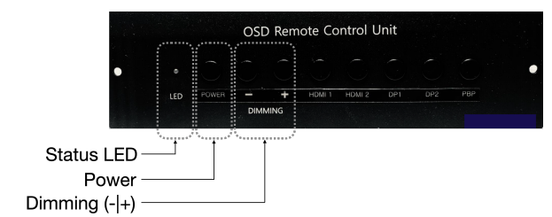

No. | Test |  | Criteria | Result | Judgment
 |  |  |  |  | Pass | Fail
2 | Verify whether the brightness can be adjusted by pressing the “-” and “+” buttons located at the lower right corner of models TIMX-W270 and TIMX-W320 |  | Brightness adjustable |  | v
 | For reference | 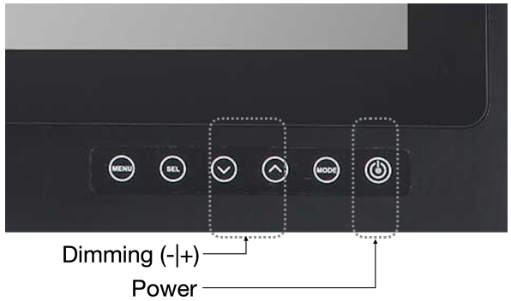

    - Keyboard with Trackball
No. | Test | Criteria | Result | Judgment
 |  |  |  | Pass | Fail
1 | Verify that the keyboard inputs function correctly. |  |  | v
2 | Verify that the mouse clicks function correctly. |  |  | v

    - Software Installation Check Test
No. | Test |  | Criteria | Result | Judgment
 |  |  |  |  | Pass | Fail
1 | Verify that HiNAS Control Standard SW is running on the monitor. |  | HiNAS Control Standard SW is running on the monitor. |  | v
2 | Double-click ‘Avikus HiNAS’ Icon on the desktop to open the login screen, log in with the provided default account |  | Login operates normally. |  | v
3 | Reboot the HiNAS Control Standard client PC and verify that the web browser automatically launches upon boot. |  | HiNAS Control Standard automatically launches after reboot. |  | v
4 | Verify the Ubuntu OS version of the server and client PCs using the ‘lsb_release -a’ command in the terminal. |  | Ubuntu 22.xx  (x is 04 or higher) |  | v
 | For reference | 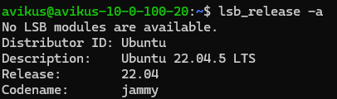
5 | Verify that the Version text at the lower left corner of HiNAS Control Standard matches the SW installation package. |  | Version v1.x.x  (x is 0 or higher) |  | v
 | For reference | 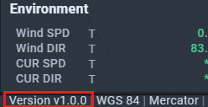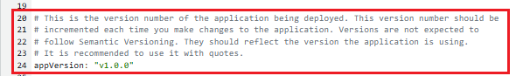

    - System Integration Test
All signals are applied to the firewall, network switch, and Serial to Ethernet device to verify the proper operation of the HiNAS Control Standard whole system. Software functions are being checked, and the related items can be verified in the ‘Onboard Test Procedure document.’
- Performance Tests
- System Health Check Test
- Basic Functionality Test
- Route Planning Test
- Autopilot fail test
- Sensor interface fail test
- BMS Fail Test
- Power Fail Test
- Operation Mode Change Test – Mode Selection Unit
- Operation Mode Change Test – SW Button

    - Power failure test
Verify the operation of the UPS backup power when the input power is disconnected
No. | Test | Criteria | Result | Judgment
 |  |  |  | Pass | Fail
1 | Upon disconnection of the input power to the UPS, the system shall remain operational via the UPS backup power. | Normal Operation upon UPS Input Power Disconnection |  | v

    - Verification of Serial Number
No. | Test | Criteria | Result | Judgment
 |  |  |  | Pass | Fail
1 | Verify the HiNAS Control Standard serial number and the presence of the Wheel Mark by inspecting the nameplate on the server. | Serial Number and Wheel Mark Labeling |  | v

RESULT |  | A
“A”: Accepts, “B”: Accept with following comments, “C”: Canceled, “R”: Reinspection
Signature | Avikus
 | 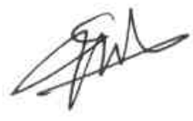

Appendix A.
- Wiring Diagram
